 SIRS 101 AND 121 TRAVEL IN 2017-18 □
"The world is a great place. You should see it!"
SIR 101and 121: Bill Britton
(925) 200-1062 or bill.britton@comcast.net

Here is some information on trips I’m planning for 2018. First, the Springtime Tulip River Cruise in the Netherlands and Belgium the and second the Christmas Market River Cruise on the Danube. Below you will find some of the details. Here is some information:

Spring Tulip River Cruise - April 2018
Featuring Dutch and Belgium Waterways
Highlights….
Amsterdam ● Volendam ● Hoorn ● Arnhem ● Middelburg ● Ghent ● Bruges ● Antwerp ● Kinderdijk ● Utrecht
9 Day and 20 Meals
Included in the price:
Roundtrip Airfare, Cruise, Insurance, Air Taxes, Hotel, Hotel Transfers, Transportation to/from SFO from Livermore
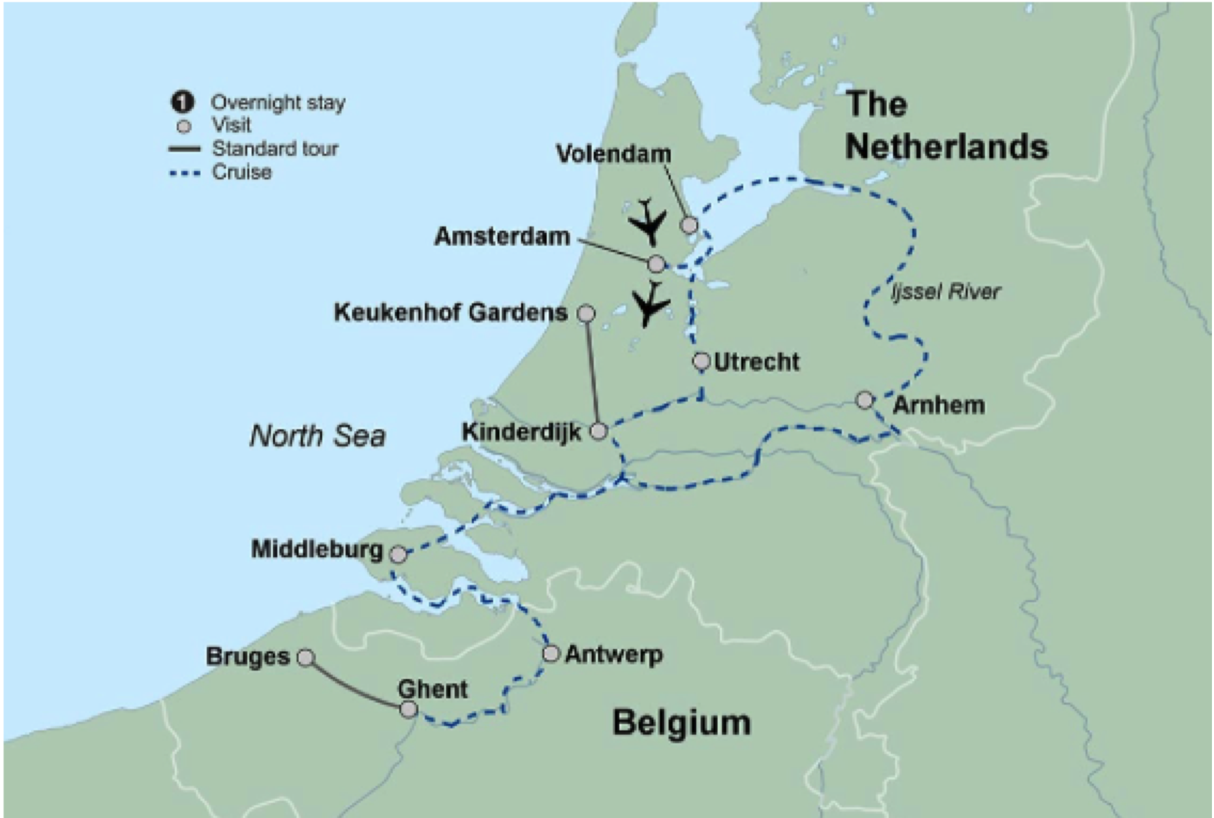

Christmas on the Danube
featuring a 6-night Danube River Cruise
Highlights….
Vienna ● Vienna Opera House ● Hofburg Palace ● Wachau Valley ● Glühwein Party ● Passau ● Regensburg ● Nuremburg ● Würzburg
9 Days ● 19 Meals: 7 Breakfasts ● 5 Lunches ● 7 Dinners

(I will probably include an extra night and day at the beginning of the trip. I plan to include the optional 2-Night Magical Christmas Markets of Prague Post Tour Extension which will be added at the end of the above highlights.)

Included in the price:
Roundtrip Airfare, Cruise, Insurance, Air Taxes, Hotel, Hotel Transfers, Transportation to/from SFO from Livermore

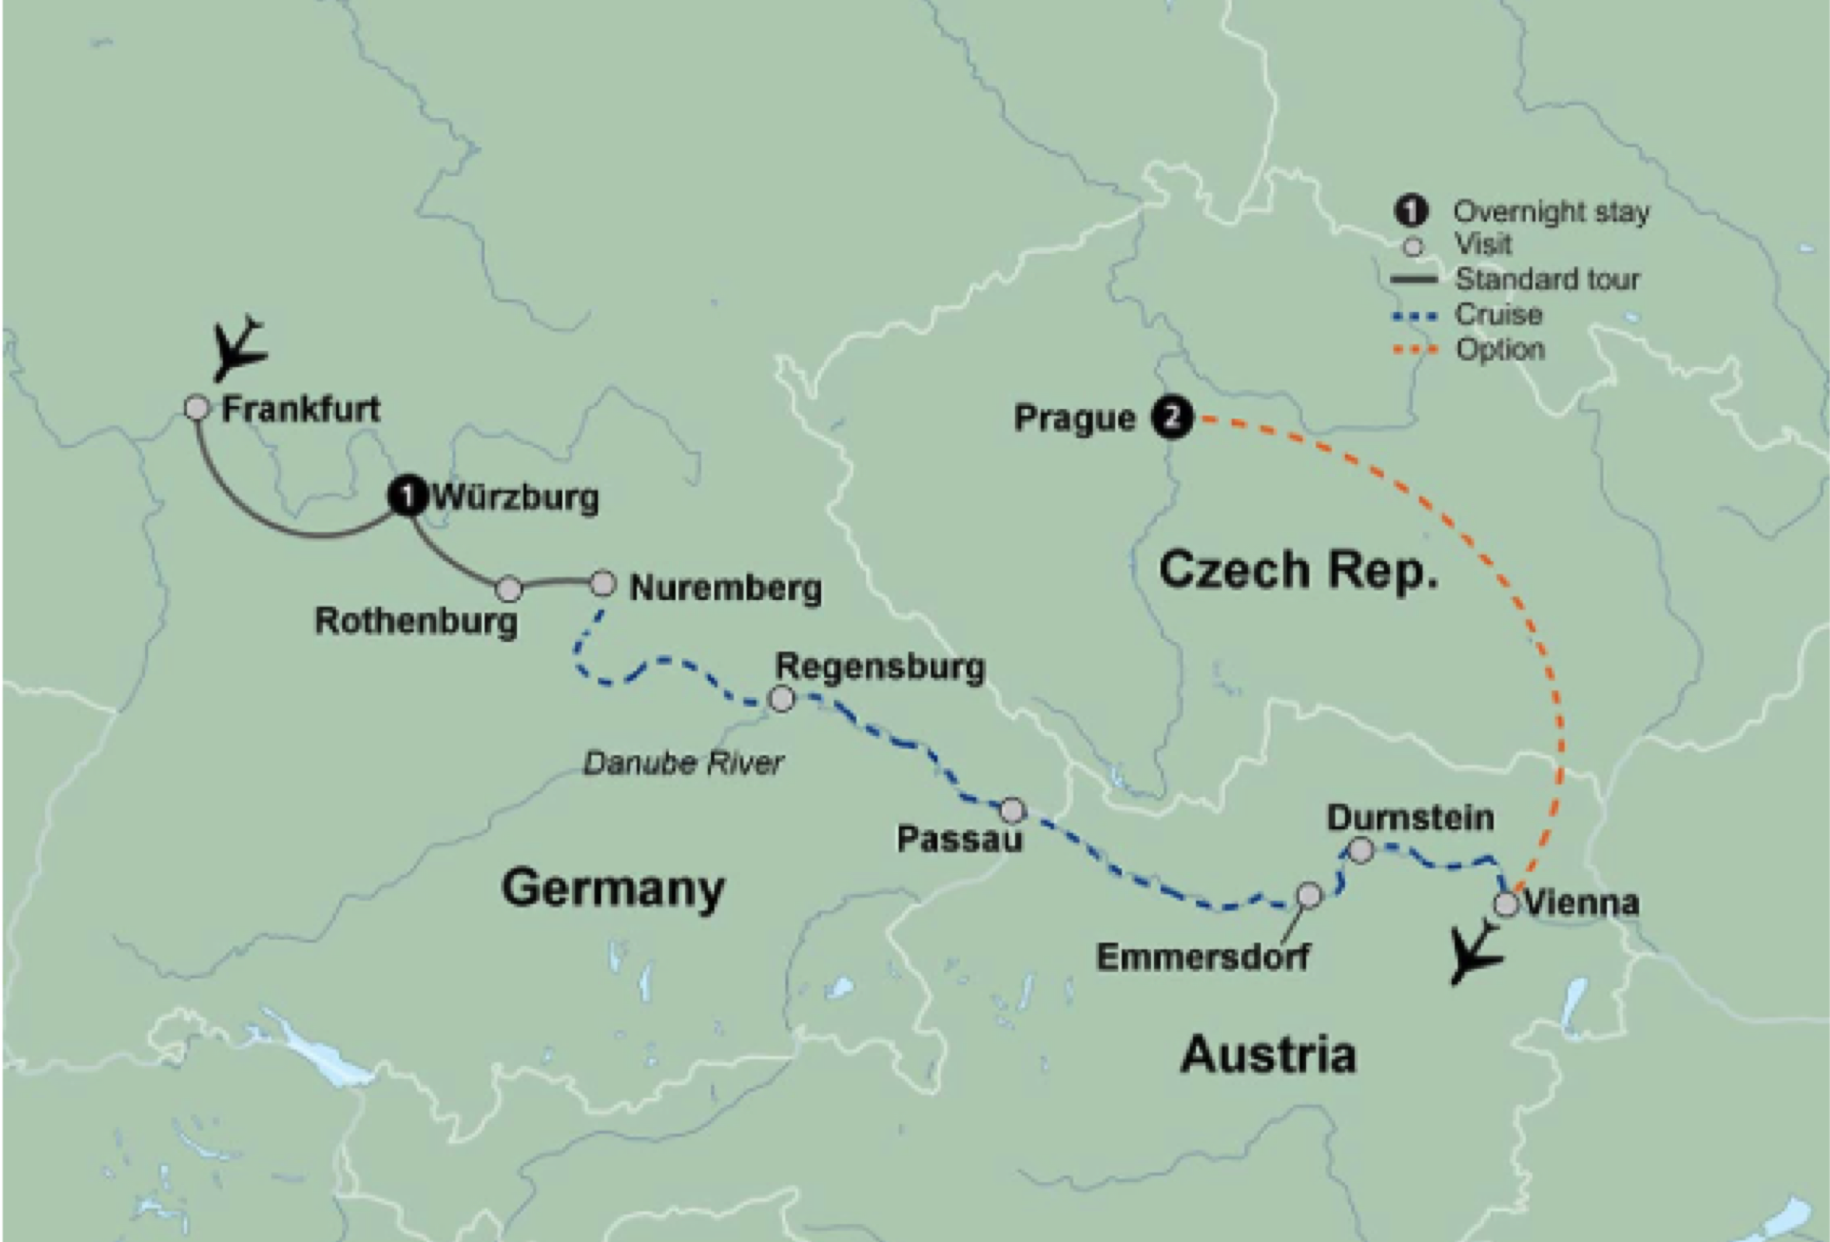

Check out the SIR website for other trips at: http://www.sirinc.org/new_site/travel.html

